SCOUT software update tool
User information


Status | In Work
Version | 1.0 / 004
Date | February 14, 2006

Responsible | Seweryn Makuch | PHE R&D SWK DL WRO
Author(s) | L&T Infotech  Marek Kocik | PHE R&D SWK DL WRO
Release | <<Name>> | <<Department>> | <<Date>>

Contents
SCOUT – Operator’s tool 3
1.1 Introduction 3
1.2 How to Use this tool 3
1.3 FAQ 5
2 How to create SCOUT bundle 7
3 Release notes for bootcore x85 (Sgold2) 8
4 Release notes for bootcore x75 (Sgold2) 9
5 Release notes for bootcore (Sgold lite) 10
6 Bootcore that should be used 11
7 Preparing the mobile for the Customer Update 12

SCOUT – Operator’s tool

Introduction
SCOUT is a Windows® based Software Update tool which is used to update the Mobile SW, Flash File system and the Mapping file to mobile phones in the Operator’s place.

How to Use this tool
- Connect the mobile with Personal Computer either through serial data cable (DCA-500), USB-Serial converter (DCA-510), Boot adapter or through USB- data cable.
- Make sure that Mobile is having enough battery power before continuing the software update. To get a full battery power, at least you need to charge for maximum of 2 hours. (from empty to full load)
- Switch ON the Mobile manually.
- Load the given executable to the local drive of your PC or to the Desktop.
- Execute the given executable by double clicking on the exe and the following window will appear in the screen. The GUI shows the version number of the tool and name of the tool. The right side window will show all the file information which is incorporated already in the tool. The Mobile SW, Flash File system, Map info and Delta Map file version and product details are shown in the right pane window.

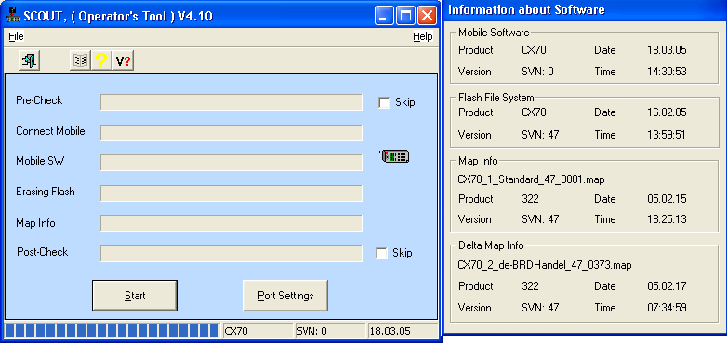

- After connecting the Mobile to the PC through Standard COM port or USB port, Press the Port settings button to configure the port to achieve the software update. The following window will appear.
If the standard COM port is used to update the mobile Software, select the desired COM port number from the GUI and select the desired baud rate and press “OK” button.
NOTE:
- The setting of the COM port can be only once. Whenever you are starting this tool, by default the last time selected port will be taken in to account. So no need to select the port once again unless until you want to change the port.
- Only one Mobile can be updated at a time.
- If the Mobile is connected with the USB cable (Mobile should be switched on), you will get a port name which includes the ‘usb’ string as shown in the following diagram. If you unplug the USB cable, this port will disappear automatically.

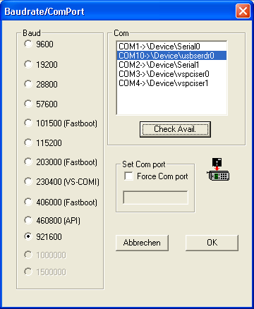

- Once the Port settings over, press START button in the GUI. All the software information will start to load to the connected Mobile. While doing Update, no need to change any of the settings available in the GUI.
- Once the successful update is happened, you will get a confirmation message in the GUI. Then disconnect the Mobile (NOTE: The Mobile will be in switched-off condition)
- Suppose, if you want to do the software update to another Mobile, connect the mobile and press the START button once again. (NOTE: It is not necessary to close the application and open once again for the second update and so on)
- In case of ERROR, you will get an error message in the application window. Please refer the FAQ section in case of error.

FAQ
- I was doing the Mobile SW update and it was interrupted by means and I am continuing the Mobile update once again but nothing is working?
While doing the mobile SW Update and it is interrupted by means, please do the following.
- Check the SKIP buttons as shown in the following GUI.
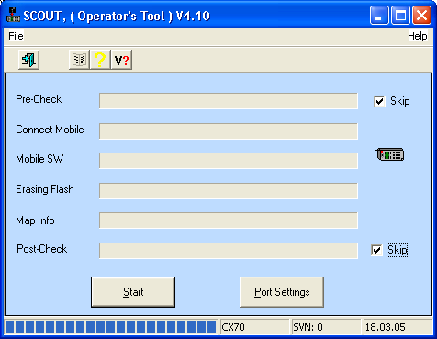

If the mobile is connected with serial data cable:
- Switch off the Mobile. To be sure, remove the battery.
- Make sure that the proper the COM port is selected by clicking the Port settings button.
If the mobile is connected with USB data cable:
- Click on the Port settings button.
- Select the Force COM port option and enter the COM port number manually (the port no which was earlier selected).
- Then Try to switch-on the mobile several times, by the same time press the START button in the GUI. Since it is a recovery update, you may find difficulties to get synchronization in this activity.

- You will get the following message while doing this operation. Press OK and software update will start to continue.
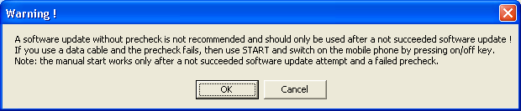
- Once the SW update is successfully done, you will get a confirmation message.

- What can I do, if I get any Error?
While working with this tool, if you get any error, the error description will be showed in the application window. The following errors very common & we have given the solution also with the error.
  - Could not ping the Mobile.
The possible reasons are the connected mobile is not switched–on properly or it is connected to another COM port. Make sure that Mobile is switched ON properly. Check the Port settings.
  - Can’t connect to Mobile with BootstrapLoader on Com3
Check the port settings and select the proper port and try once again. Take care that no other application is using the port (Mobile phone Manager, BFC application etc.)
  - Battery power is too low. Please charge fully!
You are having very low battery power in the connected Mobile. Please charge fully and try to the update once again. It could take max 2 hours to full charge.
- Unknown BFC answer from mobile, service not supported from mobile
The scout update is not supported by the mobile SW in your mobile. Use Winswup application to update the mobile to an up to date stand.

  - If you find any other errors, please refer FAQ 3.

- How to report the Error / BUG?
  - Note it down the version number of the tool
  - All the software information, which was displayed in the right pane window of the application.
  - Error description in the application window.
  - Connected Mobile details (if applicable)

How to create SCOUT bundle
- Create a SCOUT Tool by executing the Scout creator tool with the necessary input files along with SCOUT stub.
  - SCOUT Creator – It is a command line based application which will create the SCOUT tool for the end user
  - The following files are accepted by the SCOUT creator tool
    - SCOUT Stub
    - Signed XBI file
    - Signed XFS file
    - Standard Map file
    - Delta Map file
  - The order of the supplied parameter should be as follows.
    - Scoutcreator scout_stub XBI_file XFS_file Std_MapFile Delta_MapFile SCOUT.exe
    - NOTE: The order should not get changed.

- Connect the Mobile to the PC either with USB data cable or Serial Data cable.
- Run the SCOUT tool.
- Select the COM port by pressing Port Settings Button. (Only one time)
- The Update will happen to the Mobiles. All the four input file contents will be transferred to the Mobile. Then Switch off the Mobile.
- If you want to continue to update to another mobile, connect it and press the START button in the SCOUT tool.

Release notes for bootcore x85 (Sgold2)

Version SVN05 (the latest)

Known issues
- Bootcore activates the Instruction caches for BOT and Mobile SW

- USB update is not possible under Windows 98SE and ME, for more information Microsoft has an article about USB problems under those Operating Systems
(http://support.microsoft.com/default.aspx?scid=kb;en-us;324537)

Release notes for bootcore x75 (Sgold2)

Version SVN05 (the latest)

Known issues
- Bootcore activates the Instruction caches for BOT and Mobile SW

- USB update is not possible under Windows 98SE and ME, for more information Microsoft has an article about USB problems under those Operating Systems. (http://support.microsoft.com/default.aspx?scid=kb;en-us;324537)

- If the connection is broken during the erase phase, it is possible that the mobile stays on, despite is high recommended to remove the battery and insert it again before trying a recovery update. To be sure the mobile is completely off.

- This bootcore is not thought to support sybley flashes. Don't try to update in such flashes the mobile could be destroyed.

- For the USB update it is necessary some changes in the Mobile software. So far these changes are in the official sw an USB update must be possible.

Release notes for bootcore (Sgold lite)

Version SVN35 (the latest)

Known issues
- This version includes the support of the software update over the air (SWUOTA) with
some bug fixes for file system cluster size.

- The bootcore also supports older projects, but the SWUOTA needs additional mobile software support.

- AMD WORKARROUND available, use this BC for such devices.

- This version also includes the update via USB cable. This possibility is only to be used under Windows 2000, XP.

- The Update sw supports Samsung Flashes.

- Due the size of the NEO sw it is only to perform customer/secured update using xbz's. The error message/warning „You are trying to update a SW for a BCORE65 into a BC65; Do you want to continue?" has to be confirmed with "yes".
- Bootcore activates the Instruction caches for BOT and Mobile SW.

- USB update is not possible under Windows 98SE and ME, for more information Microsoft has an article about USB problems under those Operating Systems. (http://support.microsoft.com/default.aspx?scid=kb;en-us;324537)

- If the connection is broken during the erase phase, it is possible that the mobile stays on, despite is high recommended to remove the battery and insert it again before trying a recovery update. To be sure the mobile is completely off.

Bootcore that should be used
Name of the mobile | Chip | Bootcore version
CX65 | Sgold Lite | x65 Version SVN35 \\mchgclv01.mp.mchg.siemens.de\dataw\projekte\PROJ\Components\Components_R65\L1\C_L1_Bootcore\_Working\C_L1_Bootcore\70_Miscellaneous\SW\X65_Plat\050718_35_SWUOTA_USB_SCOUT
CX70 | Sgold Lite | x65 Version SVN35 \\mchgclv01.mp.mchg.siemens.de\dataw\projekte\PROJ\Components\Components_R65\L1\C_L1_Bootcore\_Working\C_L1_Bootcore\70_Miscellaneous\SW\X65_Plat\050718_35_SWUOTA_USB_SCOUT
S65 | Sgold Lite | x65 Version SVN35 \\mchgclv01.mp.mchg.siemens.de\dataw\projekte\PROJ\Components\Components_R65\L1\C_L1_Bootcore\_Working\C_L1_Bootcore\70_Miscellaneous\SW\X65_Plat\050718_35_SWUOTA_USB_SCOUT
C65 | Sgold Lite | x65 Version SVN35 \\mchgclv01.mp.mchg.siemens.de\dataw\projekte\PROJ\Components\Components_R65\L1\C_L1_Bootcore\_Working\C_L1_Bootcore\70_Miscellaneous\SW\X65_Plat\050718_35_SWUOTA_USB_SCOUT
CX75 | Sgold Lite | x65 Version SVN35 \\mchgclv01.mp.mchg.siemens.de\dataw\projekte\PROJ\Components\Components_R65\L1\C_L1_Bootcore\_Working\C_L1_Bootcore\70_Miscellaneous\SW\X65_Plat\050718_35_SWUOTA_USB_SCOUT
M75 | Sgold Lite | x65 Version SVN35 \\mchgclv01.mp.mchg.siemens.de\dataw\projekte\PROJ\Components\Components_R65\L1\C_L1_Bootcore\_Working\C_L1_Bootcore\70_Miscellaneous\SW\X65_Plat\050718_35_SWUOTA_USB_SCOUT
S75 | Sgold2 | x75 Version SVN05 - \\mchgclv01.mp.mchg.siemens.de\dataw\projekte\PROJ\X75_Platform\PE-Teams\SW\05_SoftwareEngineering\50_SW_Binaries\05_Bootcore\BC_x75plat_SVN05
SL75 | Sgold2 | x75 Version SVN05 – \\mchgclv01.mp.mchg.siemens.de\dataw\projekte\PROJ\X75_Platform\PE-Teams\SW\05_SoftwareEngineering\50_SW_Binaries\05_Bootcore\BC_x75plat_SVN05
S68 | Sgold2 | x85 Version SVN05 – https://yamswasp.bme.corp.com/TOOLS/X_Weekly_SW/BOOTCORE/BC_X85/BC_x85plat_SVN05/M_x005F_x85bc_TH_V5.xbb
EL71 | Sgold2 | x85 Version SVN05 – https://yamswasp.bme.corp.com/TOOLS/X_Weekly_SW/BOOTCORE/BC_X85/BC_x85plat_SVN05/M_x005F_x85bc_TH_V5.xbb
C81 | Sgold2 | x85 Version SVN05 – https://yamswasp.bme.corp.com/TOOLS/X_Weekly_SW/BOOTCORE/BC_X85/BC_x85plat_SVN05/M_x005F_x85bc_TH_V5.xbb

Preparing the mobile for the Customer Update

1. Boot the bootcore with winswup in unsecured mode.

2. Write the eesimu block 52 from the file "fieldtest_key_r65.eel".

3. Use the BootAcess_Checker.exe (catools) to freeze your mobile.
the way to freeze is:
- Ping Mobile ( RED circle with "NF" inside)
- Freeze ( Possibly you get a warning - Ignore )
- Switch off mobile.
- Ping Mobile ( Green Circle with "FR" inside )

4. Switch mobile in normal mode.

5. You can proceed with software update.
In winswup Don't forget to set Options->Update concept -> Force Secured Mode, customer mode.
Don't skip the precheck and postcheck.

Additional notes:
- If you want to use USB be sure that the mobile is on and connected to the PC via USB cable before setting the serial in the config window.
- Recovery update using winswup is only possible with at version 4.08.
- Old winswup versions (also update tool) are not able to work with port nr higher than 9.
- There is no USB update support for windows 98, 98SE, ME.

Here’s an example how to perform a Customer Update for X75 Minos with WinSwup

Terms:
Winswup in unsecured mode: Menu/Options/Update concept: "Force BSL, unsecured mode"
Winswup in secured mode: Menu/Options/Update concept: "Force Secured Mode, customer mode"

1. Write the Bootcore with Winswup in unsecured mode with a Bootbox.
.\M_x005F_x75bc_TH_V5.xbb

2. Write the Fieldtest Key to Eesimu from File:
.\fieldtest_key_75.eel

3. Use the BootAccess_Checker.exe (catools) to freeze your mobile:
- Press Button [Ping Mobile] (Red circle with "NF" inside, means "NOT FROZEN")
- Press Button [Freeze now] (Possibly you will get a warning - Ignore)
- Press Button [Ping Mobile] (Green Circle with "FR" inside, means "FROZEN")
- Press Button [Mobile Off]

4. Swup up-to-date Mobile SW if necessary.

5. For USB update you must be sure that not old profiles are set in your PC, despite you have to Deinstall-/Install your PC USB driver:
- Disconnect your mobile from PC via USB cable
- Execute the following Driver Removal Tool (look for the official release of the driver):
\ ... \idisk\simodrmcon.exe
- Restart your PC, if prompted.
- Connect again mobile to PC via USB cable, Windows will ask for driver installation:
- Install driver from:\ ... \idisk\w2k

(For Windows XP, Win 2000 and Win NT. Win98/WinME are not supported by USB Update)

6. Switch mobile into normal mode.
Make sure it is connected via USB cable!

7. You can proceed with SW Update.
- Switch Winswup to secured mode.
- Don't skip the pre and postcheck.
- Make sure that the mobile is switched on and connected to the PC, then
in Winswup Serial Config select the connected USB Com Port
- (You can see the COM Port at the Telephon/Modem Options in Control Panel (Systemsteuerung))
- Load Signed XBI from Official release directory. (Should already be loaded in step 4.)
- Press Winswup Button: Start -> Mobile will Shut down and after some seconds USB Update will start (hopefully)

